**Experiment 2: RC Circuit Experiment Report**

**Title**: Research on RC Circuits Driven by AC Currents

**Date**: 2024-12-06

**Name**: 徐安博 XU Anbo

**Student Number**: 202283890035

**I. Introduction and Purpose**

This experiment mainly studies RC circuits driven by AC currents, analyzes the impedance characteristics of resistors and capacitors in AC circuits, and their influence on the voltage distribution and phase relationship of the circuit. Through experimental measurement and Multisim simulation, the working principle and characteristics of RC circuits are deeply understood.

**II. Theory**

1. **Impedance Formulas of Resistors and Capacitors**
   * In an AC circuit, the impedance of a resistor ZR = R∠0Ω (where R is the resistance value), and the impedance of a capacitor ZC = 1/(2πfC)∠ - 90Ω (where f is the frequency and C is the capacitance).
2. **Characteristics of Series RC Circuits**
   * For a series RC circuit, the current I = IR = IC is constant. The total impedance ZT = ZR + ZC = R - jXC (where XC is the capacitive reactance), the total source voltage VS = VR + VC, and VC = (ZC / (ZC + ZR))VS, VR = (ZR / (ZC + ZR))VS. VR is in phase with the current I, VC is out of phase with I by π/2 (90 degrees), VR "leads" VS, and VC "lags" VS. Since the capacitive reactance XC of the capacitor is related to the frequency, as the frequency increases, XC decreases, the total impedance Z decreases, and the phase angle θ decreases. The amplitudes and phase angles of VR and VC are both frequency - dependent.

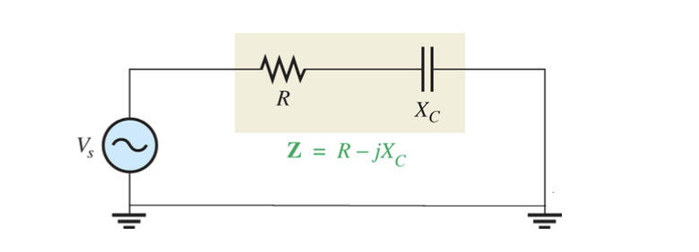

**III. Experimental Methods and Results**

1. **Experimental Methods**
   * **Experimental Equipment**: Function (signal) generator, cathode ray oscilloscope (CRO), resistors, capacitors, etc.
   * **Experimental Steps**
     + **Part 1: Actual Circuit Measurement**
       - Set the voltage output of the function generator to be approximately 2V (VS∠0V) with a frequency of 1kHz.
       - Select appropriate values of resistor R and capacitor C and connect them to the circuit.
       - Use the two channels of the CRO to measure the voltage values, pay attention to the grounding problem, measure VS (channel 1) and VR (channel 2) first, and then measure VC (channel 2) by exchanging the positions of the resistor and capacitor on the breadboard.
       - Measure and record the peak values of VS, VR, and VC, as well as the time lags τR and τC with the total voltage as the reference value, and record them in Table 1.
       - Repeat the above measurement with the frequency set to 5kHz and record the data.
     + **Part 2: Multisim Simulation and Analysis**
       - Design the circuit in Multisim with the total voltage as the reference.

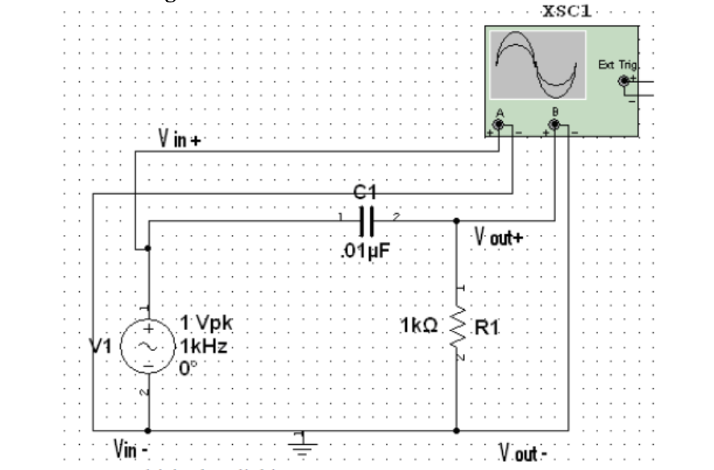

* + - * Use Multisim to measure the voltage and time lag values and record them in Table 2.
      * Plot the waveforms of VR, VC, and VS.
      * Use the Bode Plotter to obtain the Bode plot of the circuit, determine the cutoff frequency (by dragging the cyan cursor to the top left of the graph to - 3dB or right - clicking to set the Y value to - 3), and analyze the frequency response characteristics of the circuit. Further analysis can also be performed through AC Analysis. In the analysis, add the quantity to be monitored (such as Vout), view the analysis results, and adjust the properties of the graph axes as needed.

1. **Experimental Results and Discussion**
   * **Measurement Data Recording** (Fill in Table 1 and Table 2 according to the actual measurement data).
   * **Waveform Analysis**
     + From the waveform graph, the phase relationship between VR, VC, and VS can be intuitively seen. VR is in phase with I, and VC lags VR by about 90 degrees, which is in line with the theoretical expectation.
   * **Result Analysis**
     + The experimental results are basically consistent with the theory, verifying the relevant theoretical characteristics of the series RC circuit. However, there is a certain deviation between the actual measurement values and the theoretical values, which may be caused by factors such as the error of the measurement instrument and the actual parameters of the circuit components not being completely consistent with the nominal values. For example, when determining the cutoff frequency, there may be a difference between the actual measured cutoff frequency and the theoretical calculation value. By improving the experiment, more accurate components can be used, and the measurement instrument can be calibrated to improve the accuracy of the experimental results. At the same time, the Multisim simulation results are relatively close to the theoretical calculation results, further verifying the correctness of the theory, and Multisim provides convenient analysis tools, which is helpful for in - depth understanding of the circuit characteristics.

**IV. Conclusion**

Through this experiment, the theoretical characteristics of the RC circuit driven by AC currents are successfully verified, including the impedance characteristics of resistors and capacitors, the voltage distribution relationship, and the phase relationship. Through the comparison and analysis of the actual measurement and Multisim simulation, the error sources in the experiment are recognized, and the improvement direction is determined. At the same time, the application of Multisim in circuit design, simulation, and analysis is proficiently mastered, laying a foundation for future research and design of more complex circuits.